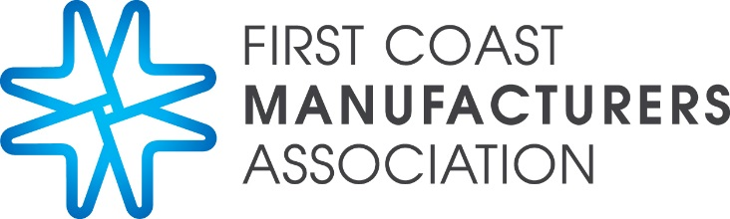
Excellence Awards: Manufacturing & Partner Members 2018
Celebrating 26 years of Excellence

Since 1992, FCMA has annually recognized outstanding companies & individuals for their contributions to the goal of manufacturing excellence and FCMA objectives, celebrating 26 years in 2018. In addition to recognizing members supportive of manufacturing, the Board of Directors may offer specific recognition to companies and individuals who make significant contributions to the betterment of our Northeast Florida community.

We invite you to partner with us in recognizing excellence by nominating yourself or another member company to be recognized in 2018!

NOMINATING
- Application fee: $100. All companies submitting applications will receive (1) ticket to the awards dinner valued at $125.00
- Nominations may be made by any FCMA member, the Executive Committee, the Board of Directors, any FCMA committee, or FCMA staff. You may nominate yourself or other members and may be nominated in more than one category. Partner of the Year is for partner members only.
- Nominees will be notified by the FCMA office as they are received and will be asked to complete the requested information specific to the award by August 31.

DEADLINES
- Nominations are open from mid-June until Friday, August 3.
- Nominee paperwork specific to award is due by Friday, August 31.

SELECTION
- A panel of three community judges has been selected by FCMA. These individuals are not FCMA members, but are familiar with FCMA and manufacturing. The judges may elect to interview the nominees or use the completed applications.

PRESENTATION
The awards dinner will be held Friday, September 21, 2018 from 5:30 PM (reception) and 6:00 PM – 9:00 PM at the University of North Florida’s Adam W. Herbert University Center in Jacksonville, FL. The event is open to all FCMA members and invitees.

AWARD CATEGORIES

- Manufacturer of the Year
1-50 employees
- Manufacturer of the Year
51-125 employees
- Manufacturer of the Year
126+ employees
- Partner of the Year
- Founders Service
- Educating the Workforce
- Protection of the Environment
- Improving the Economy

AWARD CRITERIA
Each of the company awards is based on specific criteria applicable to the award. Companies may be nominated in more than one category. The criteria are as follows:

Manufacturer of the Year
- Commitment to Improving the Economy – What is company’s approach in one or more of the following in: (Please respond in 200 words or less)
  - Development of new products and/or processes
  - Implementation of new strategies, management techniques, or methods for conducting business/work
  - Growth in revenues, sales, profitability, stock performance (if applicable) or job
- Commitment to Environmental Protection – What does company do in one or more of the following to: (Please respond in 200 words or less)
- Continuous improvement in use of materials and processes
- Education for employees on environmental issues
- Promote environmental protection to the community
- Commitment to Workforce Education - What does company do in one or more of the following: (please respond in 300 words or less)
  - Invest in employee education and training
  - Recognize and reward employees
  - Assure competitive wages and benefits
  - Create a safe and desirable work environment
  - Go above industry norm in valuing employees
  - Partner with educational and other organizations to train future workers
- Commitment to FCMA – How does company: (Please respond in 200 words or less)
  - Encourage participation in FCMA
  - Actively participate in FCMA
  - Provide member to member business

Partner of the Year
- Commitment to Improving the Economy – What is company’s approach in one or more of the following to: (Please respond in 200 words or less)
  - Development of new products and/or processes
  - Implementation of new strategies, management techniques, or methods for conducting business/work
  - Growth in revenues, sales, profitability, stock performance (if applicable) or job
- Commitment to Environmental Protection – What does company do in one or more of the following to: (Please respond in 200 words or less)
  - Continuous improvement in use of materials and processes
  - Education for employees on environmental issues
  - Promote environmental protection to the community
- Commitment to Workforce Education – What does company do in one or more of the following to: (Please respond in 300 words or less)
  - Invest in employee education and training
  - Recognize and reward employees
  - Assure competitive wages and benefits
  - Create a safe and desirable work environment
  - Go above industry norm in valuing employees
  - Partner with educational and other organizations to train future workers
- Commitment to FCMA – How does company: (Please respond in 200 words or less)
- Encourage participation in FCMA
- Actively participate in FCMA
- Provide member to member business
Founders Service
Same criteria as Manufacturer of the Year (see above), except company will be reviewed on a longer term continuing commitment in each category. The intent is to recognize companies who continually exhibit a long-term commitment to the goals and objectives of FCMA.

Workforce Education Award
Emphasis will be on specific initiatives to improve the workforce, either the company’s employees or within the community, to enhance the skills of current or potential employees.
- What does company do in one or more of the following to: (Please respond in 200 words or less)
- Invest in employee education and training
- Recognize and reward employees
- Assure competitive wages and benefits
- Create a safe and desirable work environment
- Go above industry norm in valuing employees
- Partner with educational and other organizations to train future workers

Environmental Protection Award
Focus will be on specific activities to protect the environment, at the plant location as well as community initiatives to advocate environmental protection.
- What does company do in one or more of the following to the following: (Please respond in 200 words or less)
- Continuous improvement in use of materials and processes
- Education for employees on environmental issues
- Promote environmental protection to the community

Economic Impact Award
Emphasis will be on the company’s effort to improve the economy by its performance both within the company and its impact on the larger community. (Respond in 200 words or less)
- What is the company’s experience in the following:
- Development of new products and/or processes
- Implementation of new strategies, management techniques, or methods for conducting business/work
- Growth in revenues, sales, profitability, stock performance (if applicable) or job

SPONSORSHIP
This is a unique opportunity to both promote your company and support FCMAs Outstanding Employee Awards. Sponsorship opportunities are available at the following levels: Gold - $5,000, Silver - $3,000, Table of 8 - $1,000, Half Table of 4 - $500, Additional Dinner Tickets - $125.

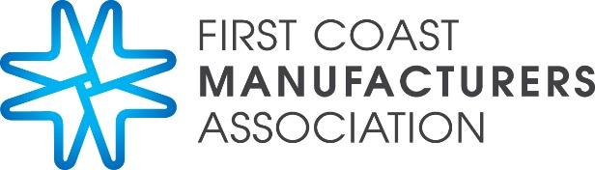

2018 FCMA Excellence Awards

Outstanding Company Awards and Outstanding Employee Awards

Friday, September 21, 2018 5:30 – 9:00 PM

University of North Florida (Adam W. Herbert University Center)

Jacksonville, Florida

Yes, I would like to participate at the following sponsorship level
Note: Please see benefit sheet for additional information.
Gold Sponsor - $5,000
Silver Sponsor - $3,000
Table of 8 - $1,000
Half Table of 4 - $500
Additional Dinner Tickets - $125.00

Name
Address
City/State/Zip
Phone / Fax
Email

Billing
Bill Me
Charge to my MasterCard / VISA credit card
Number:
Expiration Date:

Please submit completed form to Maria Corby at

maria@fcmaweb.com or fax to 904-296-9644 by August 31, 2018
For more information contact the FCMA office at (904) 296-9664
Please make checks payable to:
First Coast Manufacturers Association or “FCMA” and mail to:
1615 Huffingham Road, Suite 2 Jacksonville, FL 32216

