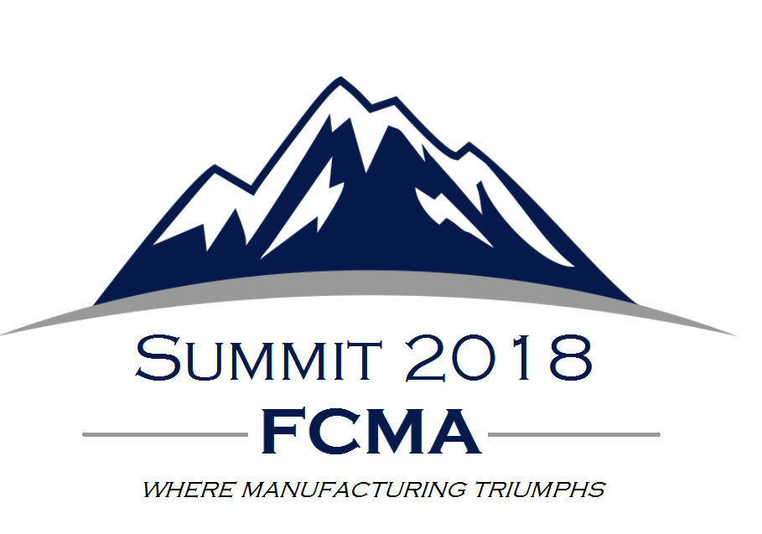

AGENDA

Thursday, August 23 – Hammock Beach Resort, Palm Coast

- 8:30-11:30AM – Summit Attendee Registration Open & Exhibit Booth Setup
- 9:00-11:00AM – Board of Directors Meeting*
- 11:45-1:30PM – Opening General Session Lunch with Keynote Speaker
  - Mark Wilson, Florida Chamber
- 1:45-3:00PM – Breakout Sessions 1 & 2
  - Key EHS Topics - An expert discussion concerning natural disasters, resiliency & sea level rise
  - Retention & Recognition - How to Crack the Code of Employee Engagement
- 3:15-4:30PM – Breakout Sessions 3 & 4
  - Cyber Security - Fool Proof: Protecting Digital Identity in the Age of the Data Breach
  - Attracting & Availability of Talent - Building Better Teams: Solving the Recruitment Dilemma
- 4:45-6:00PM – Reception & cocktail party in Exhibit Hall (Cash bar; Hors d'oeuvres)
- 6:00PM Dinner on Own

Friday, August 24 – Hammock Beach Resort, Palm Coast

- 7:30-8:45AM – General Session Breakfast with Keynote Speaker
  - Active Shooter Part 1. Speaker: Billy E Sasser Jr, CPP, Supervisory Protective Security Advisor, US Dept of Homeland Security
- 9:00-10:15AM – Breakout Session 5
  - Active Shooter Part 2. Speaker: Billy E Sasser Jr, CPP, Supervisory Protective Security Advisor, US Dept of Homeland Security
- 10:30-11:45AM – Breakout Sessions 6 & 7
  - 2018 Elections – An Academic Analysis
  - Hiring Our Heroes Made Easy
- 12:00-1:30PM – General Session Lunch with Keynote Speaker
  - Mark Vitner, Senior Wells Fargo Economist

