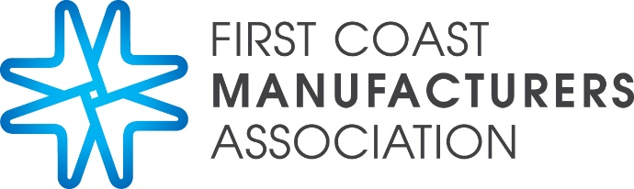

Make It Matter. Make It Here.
FCMA Symposium Agenda

Friday, May 17 – UNF University Center

- 7:00 AM – Registration open

- 7:30 AM – Breakfast begins

- 7:30 AM – 7:45 AM – Welcome

- 7:45 AM – 9:00 AM – Session 1
Manufacturing Tax Breaks and Training Dollars Available

- 9:10 AM – 10:25 AM – Session 2
Being Mickey in a Goofy World: Understanding User Attacks (Cyber Security/Ransomware)
  - Keynote Speaker: Kevin Johnson, Chief Executive Officer, Secure Ideas

- 10:35 AM – 11:50AM – Session 3
Developments in Employment Law

- 12:00 PM – 1:30 PM – Lunch and Session 4
Political Analysis with Local Talk Show Personalities

- 1:40 – 2:50PM –Session 5
Advanced Manufacturing 4.0, The Fourth Industrial Revolution

- 2:50PM – 3:00 PM – Closing Remarks

- 3:30 PM – 5:00 PM – FCMA Social Connection for Symposium Attendees. Location TBA.

