

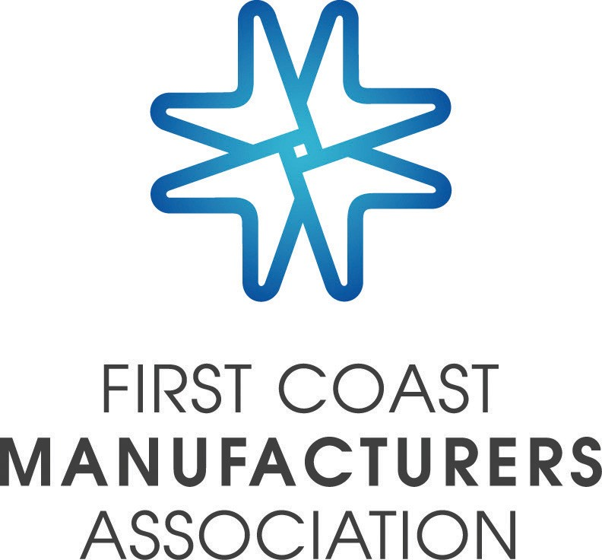

**FCMA Leadership Academy Training Program Overview**

DERSHIPINIG,

**Front Line Supervisor Training Program**

**Leading For Success—Mid-Level Managers**

* **Program designed for Front Line Supervisors, Lead Operators, Team Leaders, or future candidates for these positions in FCMA manufacturing or service oriented companies. Offering consists of eight full-day sessions occurring every 2-3 weeks over a 4-month period.**
* **Curriculum includes leadership, communications, performance coaching, team building, critical thinking and problem solving, and supervising and the law.**
* **Classes take place at rotating manufacturing locations and include instruction by UNF experts, introduction to host company businesses, plant tours to observe manufacturing best practices, and an open Q&A panel session with host company leadership team members.**
* **Program includes a kick-off luncheon and culmination graduation dinner, both with guest speakers. Lunch is provided for all classes.**
* **To date, over 350 students representing over 40 member companies have participated in this program. Feedback continues to confirm outstanding value to the individual students as well as the sponsoring companies. Program has been labeled as one of the premier leadership courses in NE Florida!**
* **Program is offered four times per year—winter, spring, summer and fall sessions.**

***- Program design in response to member needs***

***- Curriculums applicable in real life situations***

***- Course content based on best practices***

***- Offerings are continuously evaluated and improved***

A

* **Program designed for mid-level leaders who supervise managers/supervisors and have already received foundation level leadership training. The program builds on concepts from the successful Front Line Supervisor program, but takes the curriculum content to the next level.**
* **Program includes a personal DISC assessment and application of a 360-feedback tool.**
* **Offering consists of five 4-hour classes occurring every three weeks over a 3-month period plus a kick-off luncheon and a student-led culmination graduation event. In addition, each student will receive two private 1:1 coaching sessions with a trained and registered corporate coach.**
* **Curriculum includes understanding your leadership style, performance coaching, leading teams, innovation and critical thinking, and leading change. Classes will include scenarios/case studies/role-play examples, homework assignments involving interaction with student’s supervisors back at work between classes and guest speakers.**
* **Classes take place at rotating locations and include instruction by trained experts, introduction to host company businesses and an open Q&A panel session with host company leadership team members. Lunch is provided for each class.**
* **Program is offered twice per year—winter and fall sessions.**

**Introduction to Manufacturing Process Principles and Equipment**

* **Target audiences are new employees or existing employees who need exposure to basic introductory level process principles and equipment in a manufacturing environment, or manufacturing employees who have an interest in progressing into a maintenance technician career path.**
* **Curriculum includes basic training including troubleshooting tools in electricity, pneumatics, hydraulic applications, programmable logic controller (PLC) applications, and pumps and value applications.**
* **Offering consists of ten 4-hour classes taught by FSCJ instructors and occurring at the FSCJ Advanced Technology Center on consecutive Wednesday afternoon sessions over a 2-month period.**
* **Pre-and post class student knowledge assessments have consistently shown a 125%-200% increase in student knowledge on the class topics.**
* **The program is offered three times per year—winter, spring and fall sessions.**

***We here at Medtronic have been a part of the design and implementation of the Front-Line Supervisor Training program and have used FCMA for many other training opportunities. We have sent employees from a very diverse skill set s from manufacturing, engineering, and supervisory. We have nothing but good things to say about the FCMA training programs.***

***Nichole Sofge—Value Stream Specialist, Medtronic***

* **Target audiences are Supervisors, Managers, Engineers and any other employee who has little or no education or training in accounting and finance, but needs to understand basic business financial fundamentals, tools and processes. The course will represent a composite of basic economics, finance and accounting policies and principles that provide useful tools to managers and employees in their roles as project managers and decision makers.**
* **Curriculum includes introduction to economics, basic accounting principles, understanding financial statements, lease vs. buy decision making, capital budgeting and equipment purchases, overhead costs, and managing working capital,**
* **Offering consists of eight half-day sessions taught by a DeVry University professor and occurring at the DeVry University Jacksonville location every week over a 2-month period.**
* **The use of real life cases and problems will enhance the learning of and the ability to apply these concepts in the work place.**
* **The program is offered twice per year—winter and fall sessions.**

**Finance For The Non-Financial Manager**

***Vac-Con has participated in each one of these training opportunities. Our commitment to our employees, through our work force development program, allows us to continue building their knowledge base and skills through the utilization of these courses. The return on our investment has far exceeded the costs involved through these education opportunities.***

***Bob Graden—Plant Manager, Vac-Con***

***All of our employees continue to provide positive feedback on the classes they've attended.  I think Dupuy's investment in the programs you've put together will pay off for us long term.***

***Caryn Sawyer—Plant Manager, Dupuy Silo***

Contact Information: Mike Templeton Amanda Starling

(904-651-4955 (cell--call or text) (904) 296-9664

[mike@templetonms.com](mailto:mike@templetonms.com) [amanda@fcmaweb.com](mailto:amanda@fcmaweb.com)