2022 FCMA Symposium
Thursday, August 25, 2022
World Golf Village Renaissance Resort, St. Augustine, FL

Sponsorship Opportunities & Benefits
Sponsor Level | Symposium Tickets  included | Exhibitor’s  Table  Table size is 8x3 | Advertising included:  Program; Website; Newsletter; all other PR materials
Platinum Sponsorship $4,000 | 4 Tickets
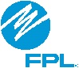  Gold Sponsorship  (1 available) $2,500 | 3 Tickets
Silver Sponsorship  (3 available) $1,500 | 2 Tickets
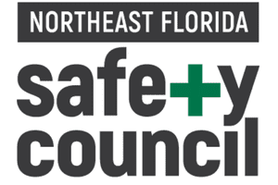  Bronze Sponsorship  (4 available) $ 500 | 1 Ticket
Exhibit Booth  (SOLD OUT) $ 500 | 1 Ticket | Table at event

Please note that the top three sponsor levels get the additional benefits listed: An invite to the Columbia Restaurant on Wednesday night (August 24) with the FCMA Leadership (Board, Committee Leaders, and staff); allowed to place literature on the resource table at the event and can reserve your seat in the meeting room. All other seats are open seating.

*All Symposium attendees must have a Symposium ticket, including person manning exhibit booth. Exhibitors may purchase additional tickets if they require them. Table size is 8x3. Booths must be freestanding only; nothing can be attached to the walls.
NOTE: Non-members could sponsor at Gold level only.

